Energy in Motion
Make a circle around the objects that burn fuel to move.
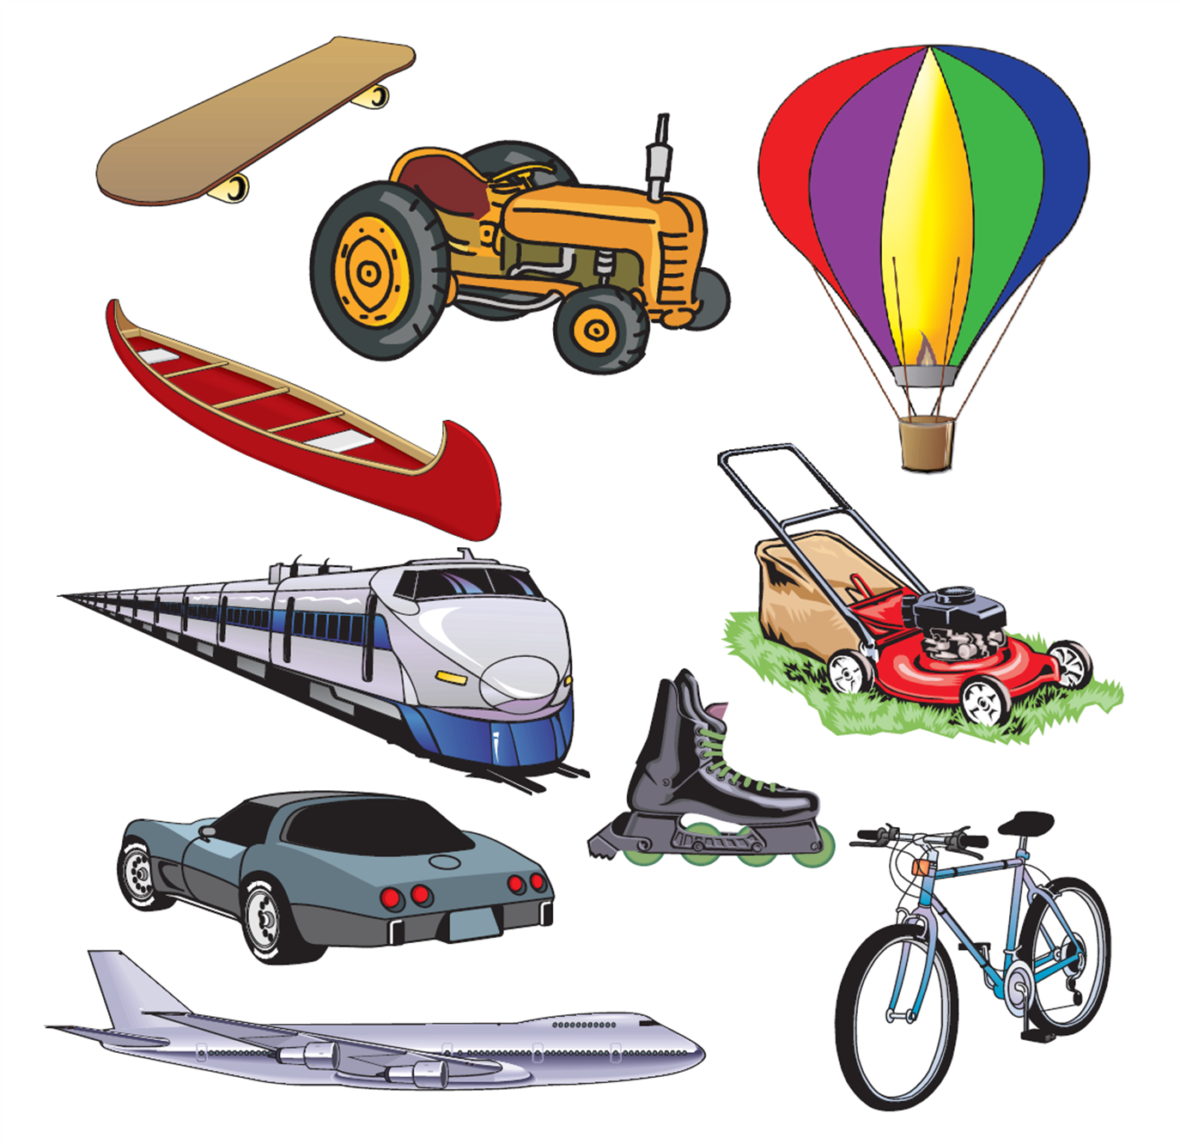
Make an X through the objects that need people power to move

