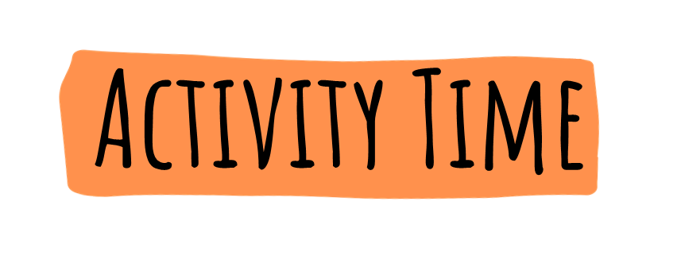

This game can be done as role-playing game in the classroom.
Your pupils will pretend to be at home.
They will then repeat the game at home with their family.
Cut out this spinner to play.
Place a paper clip on the point of the pencil and place the point of the pencil (with the paper clip) in the small white circle in the middle of the spinner.
Fling the paper clip around.
It will land on one of the sections of the spinner.
Read the comment and act accordingly.
Everyone should have a paper clip, eraser, a piece of paper with their name on it or something else small to use as their playing piece.
Now spin.
- If the paper clip dial lands on an energy conservation tip, move forward two spaces
- If the paper clip dial lands on something that uses energy, move back one space
The first player to come to the end wins the game.

