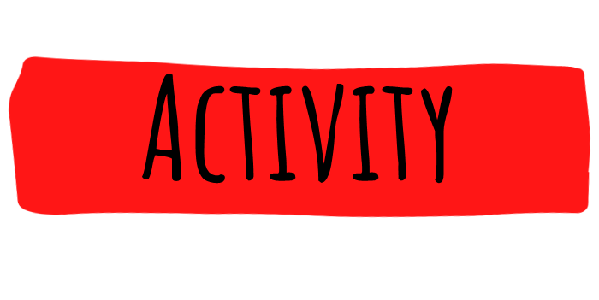

Find out more about energy waste and energy saving by investigating the topic and have fun being a reporter.
Enter the national and international YRE competition
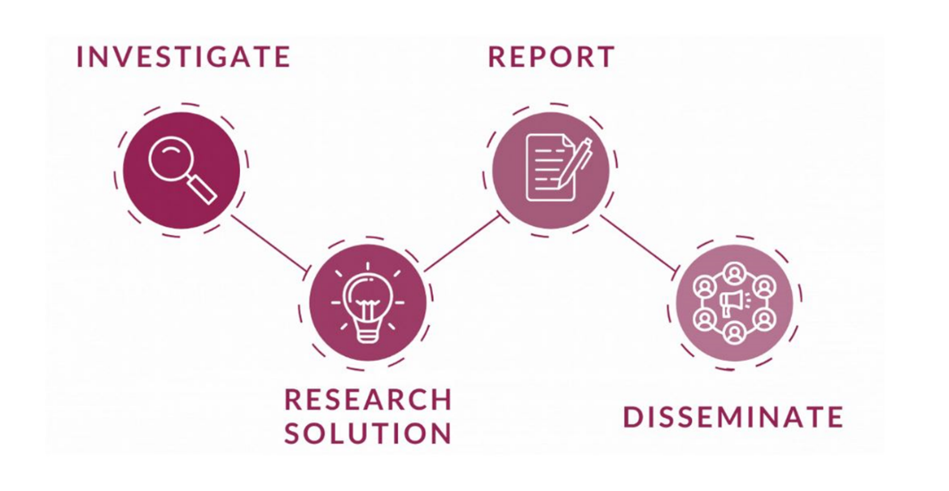

https://www.youtube.com/watch?v=5rtij3ygSk0
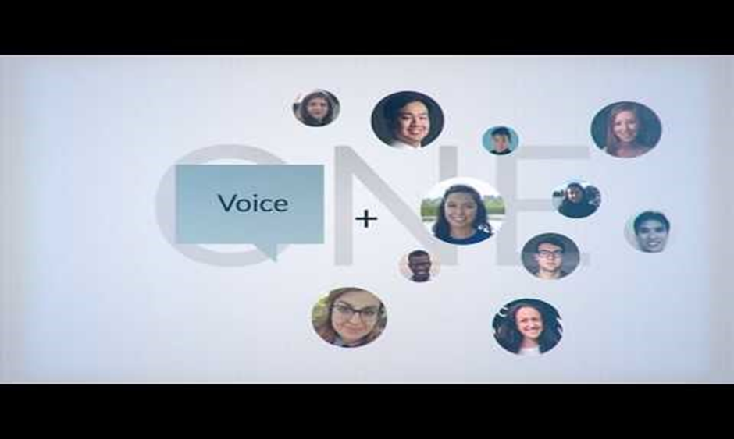

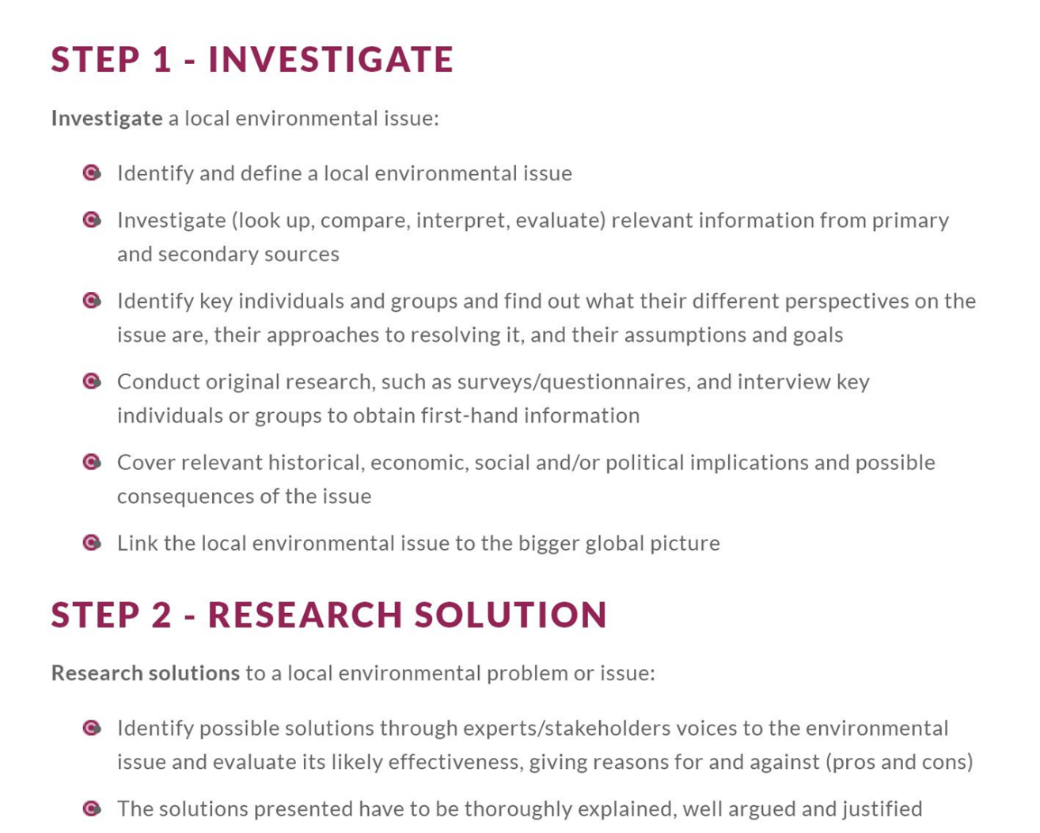

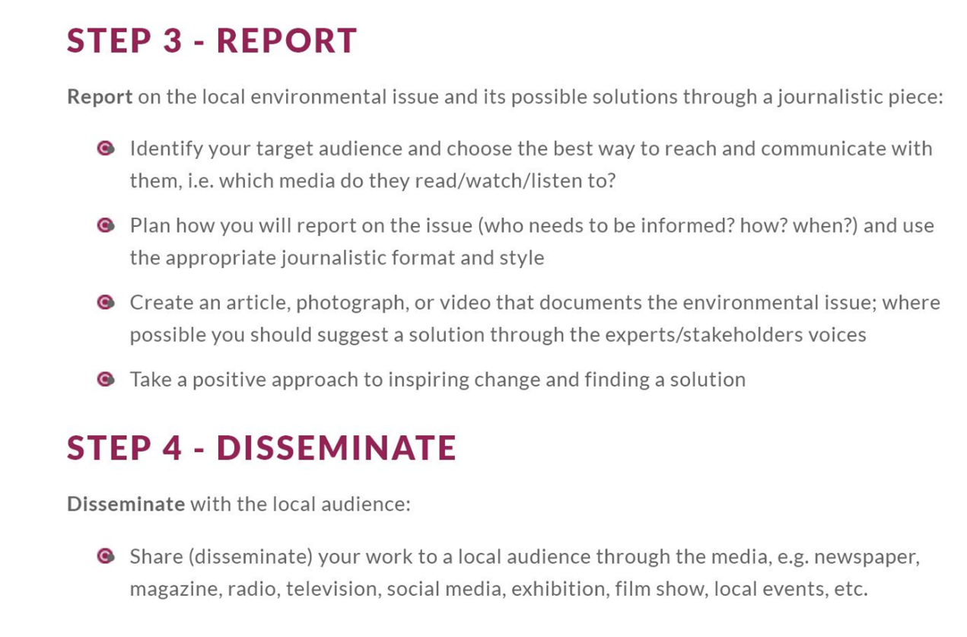

Visit our website for more info on the YRE competition
https://eco-schoolsni.etinu.net/cgi-bin/generic?instanceID=46

