Hedgerow Heroes Competition
Guidance & Application

Thank you for your interest in applying for the Hedgerow Heroes Project!

This exciting new project has been funded by Moy Park and over the next three years, will see us working with 33 schools across Northern Ireland to create hundreds of metres of hedgerows and habitats for nature across Northern Ireland. Read on if you’d like your school to take part.

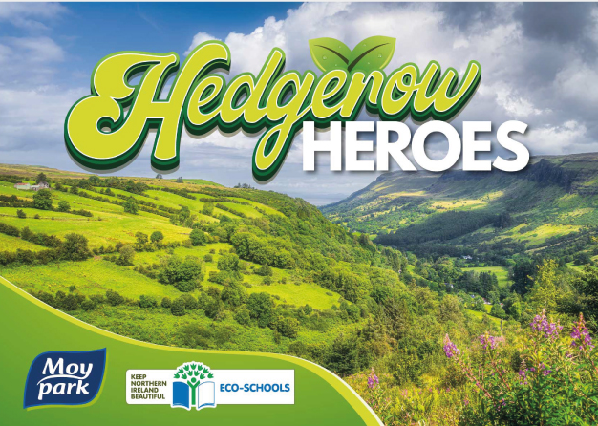

Short Summary

Keep Northern Ireland Beautiful are currently recruiting 11 schools across Northern Ireland to join this project – each of the 11 schools will receive a 20m long native hedgerow, which will be planted by the students, and 3 workshop visits from Keep Northern Ireland Beautiful staff.
You must enter the competition to be in with a chance of being selected for this project (further details are below).

Why are hedgerows important?

Northern Ireland’s Biodiversity is declining.
11% of our species are threatened with extinction from the island of Ireland.

Native hedgerows are incredibly important wildlife habitats, providing shelter and food for many species of mammals, birds and insects. Some hedges in Northern Ireland are now 100-150 years old. However, throughout the 20th century, many hedgerows have been removed in rural areas (approximately 118,000 miles of hedgerow in the UK), and also increasingly in urban areas, where it is now uncommon to see a native hedgerow providing a boundary.

The planting of hedges presents an excellent opportunity to combat habitat fragmentation, climate change and to promote biodiversity recovery. Some hedgerows have been found to host more species of plants than corresponding woodland and grassland. As well as being an important habitat, they act as essential wildlife corridors, allowing dispersal between otherwise isolated habitats. Hedgerows also provide a wealth of ecosystem services such as carbon capture, air and water filtration, pest control, crop pollination, and the reduction of soil erosion and flooding. Linear landscape features, including hedgerows, are also important navigation aids for many species of bats and can even allow them to extend their foraging and roosting capacity.

Our hope is that the new hedgerows we plant will act as a way of connecting isolated habitats together as a nature recovery network. With time, they will also act as excellent places for education and provide opportunities for wild foraging.

Who can apply?

- Any school in Northern Ireland can apply to the Hedgerow Heroes Project.
- Workshops are suited to p5 upwards. We cannot accept applications from younger age groups due to the physical nature of this project.
- We can accept multiple applications from different classes in one school, but please be aware that no more than one class per school (or a mixed class group of 30 students) will be able to participate in the project, even where multiple applications are received from one school.
- Please be aware that preference will be given to schools with an area of natural environment nearby, such as a woodland, park or garden, as this is where the hedgerows will have the highest benefit for biodiversity recovery by extending and connecting habitat.
- Applications must be completed and submitted by teachers or school staff who are 18+. However, the main activities in the competition should be student led.

You can use Outdoor Recreation NI’s GreenSpace NI Map Viewer to find green spaces close to your school.

GreenspaceNI Map Viewer (arcgis.com)

What you will receive

Each of the 11 selected schools will be supported in the planting of their native hedgerow and the students will receive fun and interactive environmental education workshop sessions.
The project participants will receive 3 workshop visits from KNIB staff:

- Session 1 – Select where to plant your hedge and Workshop on Tree ID (Sept-Oct 2023).
- Session 2 – Hedgerow planting session and Workshop on Biodiversity and Habitats (Nov-Dec 2023).
- Session 3 – Citizen Science Session with Workshop on Bird ID (Big Garden Bird Watch) (Jan-Feb 2024).

- Each of the schools will also receive educational hedgerow-themed signage as part of the project to complement their new hedgerow.
- Selected schools will also receive one follow-up visit in year 2 of the programme to provide ongoing advice and support on management and maintenance of their hedge.
- Keep Northern Ireland Beautiful will also create peer-to-peer mentoring and learning opportunities between schools engaged in the Hedgerow Heroes Project.

Competition Details:

Class to submit one of each of the requirements below:

Requirement 1. One field sketch of your school site completed by pupil(s)
Sketches/drawings should be of habitats and animals you find on your school grounds.
Prompt questions:
- Do you have a hedge on your school grounds already?
- Is there a woodland nearby?
- What wildlife-friendly things do you do in your school?
- What wildlife have you seen on your school grounds?
Notes:
- You can annotate your drawing
- Your drawing can be coloured or black and white

Please submit the field sketch as a JPEG image.

Requirement 2. One short story OR 2 x written paragraphs completed by pupil(s)
Writing should be inspired by:
(i) Why you want to protect the plants and animals in your school grounds and
(ii) How you think a hedgerow would help wildlife in your area.

Please submit your short story/piece of writing by filling in the box in the application section of this document below.

Deadline for submissions 12 noon on Friday 15th September 2023

Please send you entries via email to Chris Walsh at christopher.walsh@keepnorthernirelandbeautiful.org
Please also email Chris if you have any questions about the application process.

Best of luck!

Competition application overleaf

Competition Application Form

Name of School

School Address

Council Area

Teacher’s name

Teacher’s email

Teacher’s contact no.
(optional)

Details of school group:

Age group

Number of students

Please select one:

- One class
- Multiple classes combined

Please name and/or include details of any green spaces near your school, for example, a wild meadow, park, woodland or river:

Do you have any mature hedgerows or woodland areas on your school site?
(Please select an answer)

- Yes
- No

Application continued

Requirement 1:
Please attach your field sketch to your application JPEG image along with this completed document. Acceptable file types for the field sketch include JPEG, PNG and PDF.

Requirement 2:
Please fill out your short story OR 2 x written paragraphs below (requirement 2 can also be attached to the application email as a Word doc. if preferred):

(Please do not feel the need to fill this box with text. Its purpose is to provide extra space if necessary.)

Please remember to send both requirements and the completed application form to christopher.walsh@keepnorthernirelandbeautiful.org by 12 noon on Friday 15th September 2023 to be in with a chance of participating in Year 1 (2023/24) of the Hedgerow Heroes Project.

Thank you and good luck!

