

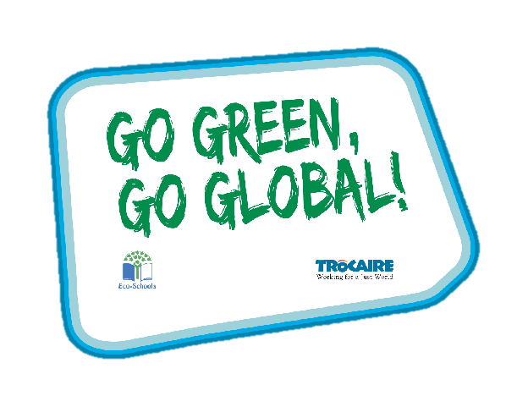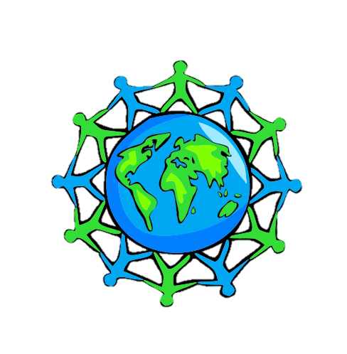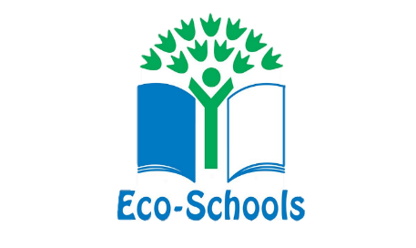

Global Perspective

Water

Climate Change

Key Stage 3

‘Whole Class Activity’ Resource Booklet

The purpose of this resource

The Eco-Schools programme in Northern Ireland is operated by Keep Northern Ireland Beautiful and addresses the following eleven topics within schools:

Biodiversity Energy Global Perspective Healthy Living

Litter Marine Transport Waste

Water Climate Change School Grounds (outdoor learning)

In order to qualify for the much acclaimed 'Green Flag' award level, schools must have shown substantial progress towards completing 'one large scale project topic and indicated involvement with two others'.

Through the expertise of the Irish development agency Trocaire, this resource provides a range of activities to incorporate a global perspective into the classroom. It will focus on three of the eleven Eco-School topics and will explain how to introduce and explore these global issues with your pupils.

Each section contains an information sheet on the global issue and one whole class activity.

**Content**

**Section 1 – Global Perspective 3-12**

**Section 2 – Water 13**

**Section 3 – Climate Change 14-16**

Section 1: Global Perspective

**Key stage 3**

**Background: Global Citizenship**

Being a global citizen is not clearly defined. As there is no global government there are no clear rules and regulations and globally, we do not have democratically elected representatives to speak for us.

Global citizenship is more a moral understanding of our responsibilities and our rights in a global context. Being a true global citizen means that we recognise that all people have equal rights and value diversity.

In addition, it means we should value planet earth as our common home and one which we all have a need and indeed a responsibility, to look after.

**Background: Global Population**

Our precious finite world is currently home to over 7.8 billion people. Numbers this big are difficult to understand but what if we imagined the whole population of the world as a village of just 100 people? In this imaginary village, each person would represent about 78 million people from the real world. One hundred people would fit nicely into a small village. By learning about the villagers – who they are and how they live – perhaps we can find out more about our neighbours in the real world and the problems our planet may face in the future.

Imagining the world as a village also makes it easier for us to start thinking about all the human and environmental problems in the world and what we can do about them. It makes it easier for children to grasp the concept that the world is a large place, and many people in the world live lives much different from our own.

**Exercise 1: If the world were 100 people**

***Aim:*** to grasp the concept that the world is a diverse place and to become aware that many people in the world live lives much different from our own. To look at our relationship with the wider world.

***Materials:*** Internet connection to play the video, photocopies of the worksheet and pens

**Step 1:** Watch the internet video as a class.

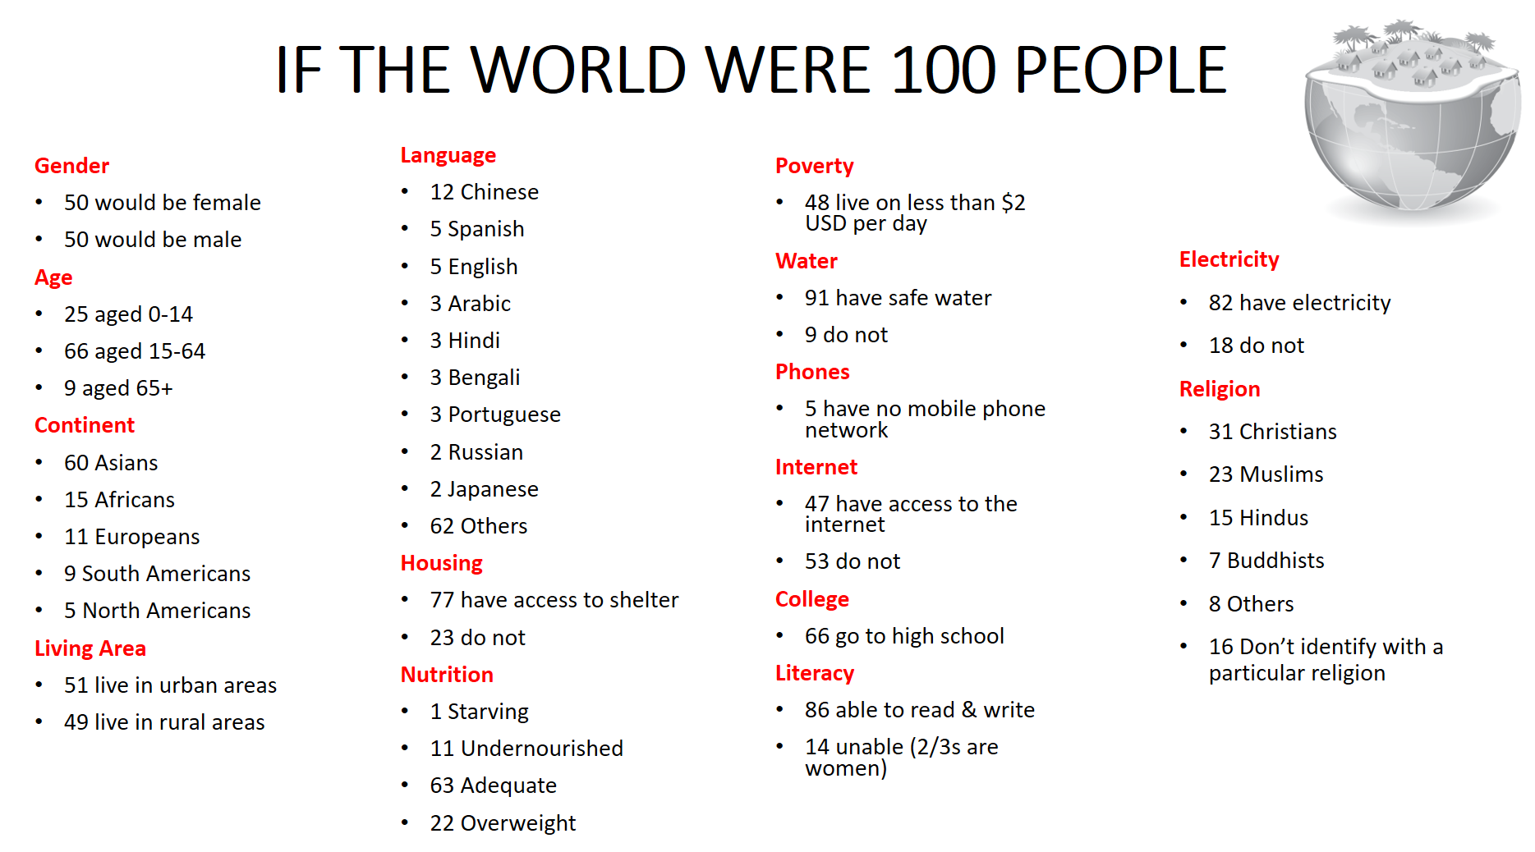**Step 2:** Give pupils the worksheet and in pairs or small groups ask them to fill in the blanks. See below for correct answers.

Using the following numbers fill in the blanks. The first one has been completed for you. Remember to circle them once you have used them.

|  |  |  |  |  |  |  |
| --- | --- | --- | --- | --- | --- | --- |
| 60 | 12 | 23 | 15 | 11 | 47 | 0 |
| 16 | 14 | 5 | 12 | 18 | 50 | 15 |
| 5 | 50 | 23 | 31 | 5 | 9 | 3 |



**60** Asian People

African People

European People

are from South America, Central America (including Mexico and the Caribbean)

from Canada and the United States

from Oceania (Australia, New Zealand + islands of the south, west & central Pacific)

females males

speak English speak Chinese speak Hindi speak Spanish

are Christian are Muslim are Hindi don’t identify

people do not have enough food to eat

have access to the internet

do not have access to shelter

do not have access to electricity

unable to read and write

**Background: Global Food**

There is plenty of food in the world to feed everybody. The problem is how this food is distributed and shared.

In fact, more than one and a half times the amount of food needed to feed everybody in the world is produced each year**.** Yet over 821 million, 1 in 9 people, are hungry.

If there is really enough food in the world, why do some people still go hungry?

Hunger is caused by many factors and must be solved with many approaches. Factors include lack of investment in small farmers, particular women, unfair international trade policies and climate change.

**Exercise 2: How far did my food travel?**

***Aim:*** To become aware of the journeys which foods take from source to consumer and the importance of buying Fairtrade.

***Materials:*** worksheet, blank world map, pencil and colours, access to internet or an atlas

**Step 1:**Explain to pupils that much of the food we eat and the drinks we drink aren’t

produced locally and are in fact transported from countries all over the world.

**Step 2:**Give pupils out a blank world map and have them use atlases or the internet to locate each of the 14 countries.

**Step 3:**Draw and colour the correct food to label the country.

**Step 4:**Use the internet to calculate the miles the food travels to get to Northern Ireland and record in the table.

**Step 5:**Use the PowerPoint to go through the answers and show the map.

**Step 6:**Discuss with pupils how expensive it must be to package and transport these foods to us and we only maybe pay less than a pound for it. How does the farmer make any money? This is your introduction into Fairtrade.

**How Far Did My Food Travel?**

The food below cannot be grown in sufficient quantities in the UK and Ireland and so are imported from other countries. Locate and mark these countries on your map, drawing and colouring a picture of the food that is grown there.

Using the internet, can you work out how many miles these foods must have travelled to get to Northern Ireland?

|  |  |  |
| --- | --- | --- |
| **Food** | **Country imported from** | **Miles to Northern Ireland** |
| Bananas | Ecuador |  |
| Green beans | Kenya |  |
| Coffee beans | Brazil |  |
| Tea | India |  |
| Lemons | Spain |  |
| Sweet potatoes | USA |  |
| Olives | Italy |  |
| Pineapples | China |  |
| Lamb | New Zealand |  |
| Rice | Indonesia |  |
| Coconuts | Philippines |  |
| Garlic | South Korea |  |
| Chilli Peppers | Mexico |  |
| Apples | Poland |  |

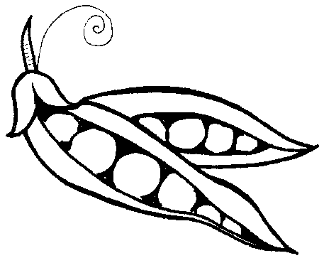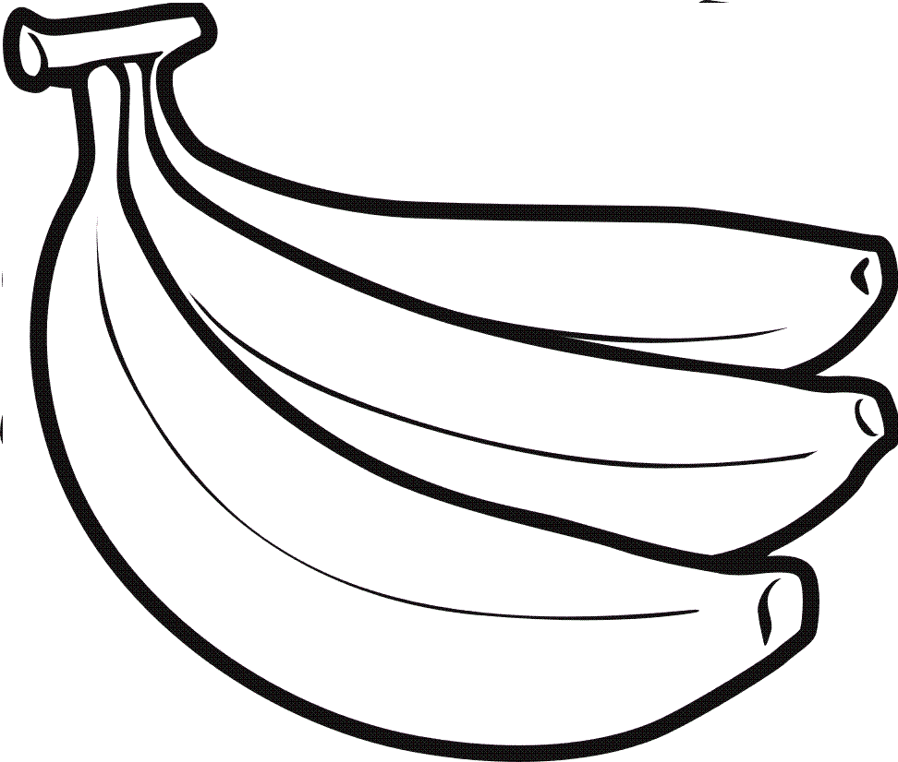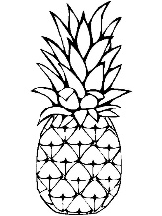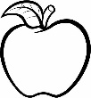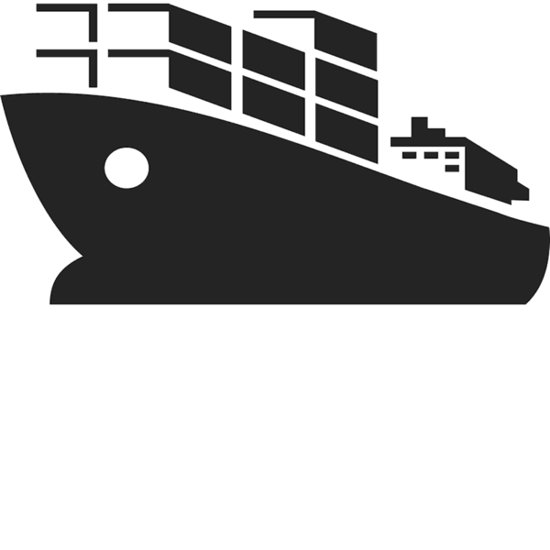

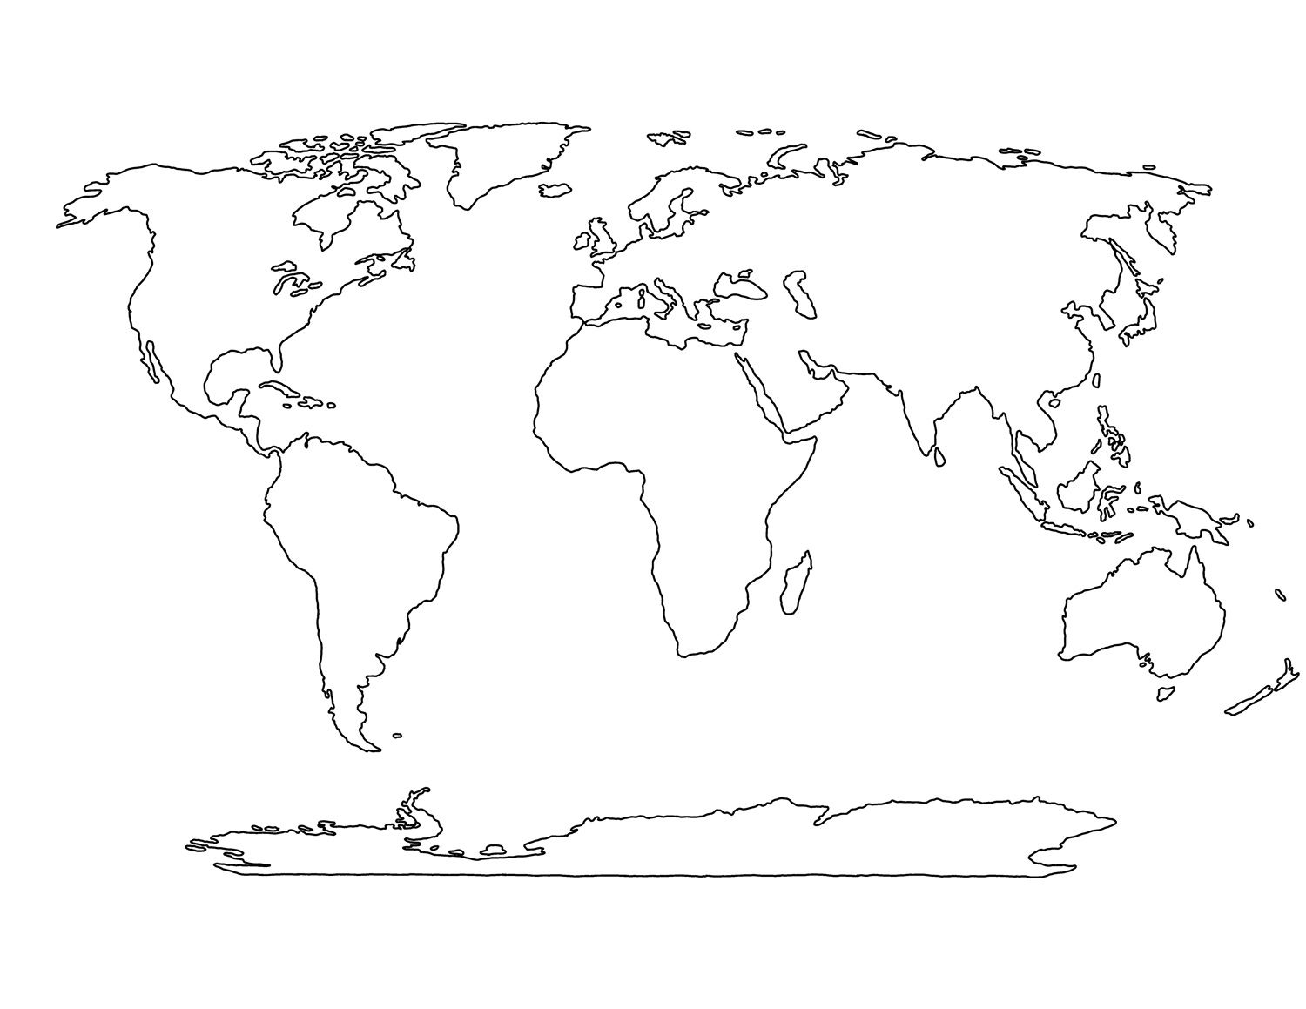

**World Map**

**Background: Trade/Fairtrade**

Trade: One of the causes of hunger is unfair trade rules. When we talk about trade, we are referring to how countries buy and sell goods and services. By buying and selling goods and services countries receive income. This income is used to improve a country’s standard of living by investing in public services such as roads, hospitals and schools. But who trades? Individuals, companies, governments...almost everyone, in some shape or form, is involved in buying and selling goods and services, in order to, satisfy their needs and wants.

FairTrade guarantees a better deal for developing world producers. Buying Fair Trade products, you can ensure that the injustices to the producers are reduced. Fair Trade is also about sustainable development: producer organisations are encouraged to continuously improve working conditions and product quality; to increase the environmental stability of their farming methods; and to invest in the development of their organisations and the welfare of their works. The FairTrade logo is only awarded to producers that have a trade union, obey health and safety rules, protect the environment, and do not allow children to work.

**SUSTAINABILITY SUPERSTARS**

***FORESTS FOR ALL FOREVER* -** The Forest Stewardship Council is an international non-profit, multi-stakeholder organization established in 1993, that claims to promote responsible management of the world's forests.

Reuse, Repair, Refuse, Reduce, Recycle – Universal recycling symbol.

***Fairtrade*** is an arrangement designed to help producers in developing countries achieve sustainable and equitable trade relationships. Members of the fairtrade movement add the payment of higher prices to exporters, as well as improved social and environmental standards.

***Rugmark*** is a global, not-for-profit organisation dedicated to providing a better life for thousands of children working illegally in the rug industry across South Asia.

***Traidcraft*** is a UK-based Fairtrade organisation, established in 1979. The organisation has two components: a public limited company called Traidcraft plc, which sells fairly-traded products in the United Kingdom; and a development charity called Traidcraft Exchange that works with poor producers in Africa and Asia.

The ***Rainforest Alliance*** certification seal means that the product (or a specified ingredient) was produced by farmers, foresters, and/or companies working together to create a world where people and nature thrive in harmony.

**Exercise 3: Logo Lookout**

***Aim:*** to examine the role of advertising & marketing at a local and global level

***Materials:*** Photocopies or downloaded versions of logos on Pupil Worksheet, pen for each pupil. (Use recycled paper)

**Step 1**: Give pupils worksheet. Ask them to try and identify the 5 logos. Do they recognise any of the logos? Discuss what the logos mean. Record any comments and explanations.

**Step 2:** Ask the children to bring in labels from home which display any of the logos on them. What types of products hold the different logos?

**Step 3:**Make a display for the school foyer to encourage others to buy Fair Trade. Create imaginative headlines for example ‘We buy Fair Trade…Why don’t you’?

****What do these logos mean?**





1. ***_______________ 2. _______________ 3. _____________***





***4. __________***

***5. _____________***

***5 Things I can do to promote FAIR TRADE***

***1. ______________________________________________________________________________________________________________________________________________________________________________***

***2. ______________________________________________________________________________________________________________________________________________________________________________***

***3. ______________________________________________________________________________________________________________________________________________________________________________***

***4. ______________________________________________________________________________________________________________________________________________________________________________***

***5. ______________________________________________________________________________________________________________________________________________________________________________***

***See how to become a Fair Trade School*** [***www.fairtrade.org***](http://www.fairtrade.org)

**Exercise 4: A pair of Nike trainers sells for $100.**

**How would you divide the money up?**

***Aim:*** to examine how fairly the $100 is divided among the different people involved in the produce and sale of a Nike trainer.

***Materials:*** PowerPoint

**Step 1**: Facilitate a discussion around the different parts of a Nike trainers, journey from the materials right through to it being sold.

**Step 2:**Divide pupils into small groups to discuss how they would divide the $100 between 7 groups and be able to explain why they decided on it.

**Step 3:**Have a person from each group feedback their decision and explain why.

**Step 4:**Show them the real figures and discuss the inequalities around this.

Section 2: Water

**Background information**

Water is an extremely important natural resource in our everyday lives. Our bodies are 70% water. Without it, we would die within 3 days. The Earth is also 70% water, however, only 2.5% of it is fresh water. Moreover, only 1% is easily accessible to us as most of it is trapped in glaciers. Living in Northern Ireland, we are often unaware of the current water crisis that exists in our world. We simply have to turn a tap to get water. Contrastingly, women in Africa and Asia walk on average 6km a day to collect water. Furthermore, one sixth of the world's population lacks access to safe water and 40% lack adequate sanitation. With a growing population, demand for water resources increases.

**Exercise: Water scarcity around the world**

***Aim:*** To become aware of the different types of water scarcity experienced across the planet

**Step 1:**Create 3 stations around the room. Set up materials for each station:

**Station 1** (Water Abundance): 3 cups labelled agriculture, human needs and recreational uses (placed in a bowl for overflow), 1 large jug of cotton balls (dyed blue to represent clean water)

**Station 2** (Physical water scarcity): 3 cups labelled agriculture, human needs and recreational uses, 1 small cup for collecting ‘water’, small bucket containing a few cotton balls

**Station 3** (Economic water scarcity): 3 cups labelled agriculture, human needs and recreational uses, 1 very small cup for collecting ‘water’, small bucket, located at the opposite side of the classroom, containing cotton balls (dyed black to represent unclean water) and 1 large jug of cotton balls (dyed blue) – marked with an X (cannot use)

**Step 2:**Separate the class into 3 groups, rotate the stations every 5 minutes. Ask the students to divide the ‘water’ into the 3 cups and take notes at each station describing their experience. Think about the challenges you may have encountered during the process? How did you divide the ‘water’ between the 3 sectors? What were your reasons? Describe the quality of water and how it would have an impact on your current lifestyle.

Section 3: Climate Change

**Background information**

While weather can change dramatically in the course of a day, climate usually takes thousands of years to change. The climate is changing more quickly than before, therefore, it is becoming a major concern. Climate change is heightened as a result of increased human activity on Earth. People are using too much of the Earth’s natural resources. Everything we do in life will have a positive or negative effect on climate change. Ultimately, the more we consume, the bigger our carbon footprint becomes. Knowing a person’s carbon footprint and how it compares to the carbon footprint of others can help pupils to identify how the Earth is impacted by their actions and how they can reduce their carbon footprint.

**Exercise: Carbon footprint…What size is yours?**

***Aim:*** To be self-aware of your carbon footprint and the effect it is having on the Earth, regarding increased climate change

***Material needed:*** Carbon footprint worksheet, computer.

**Step 1:**Ask the children if they know the meaning of the phrase ‘carbon footprint’. If necessary, explain that carbon footprint is the amount of carbon a person uses on average. Every time we use Earth’s natural resources, carbon dioxide is released into the atmosphere, causing the planet to heat up.

**Step 2:** Complete the worksheet by colouring the area which most applies to your life. The outer circle represents the first statement in each text box and the inner circle represents the last statement in each text box.

**Step 3:**At the beginning of the year, create a wall display using the completed ‘my carbon footprint’ worksheets to create awareness of how everything you do affects your carbon footprint.

**Step 4:**Explain to the class that a healthy planet can provide enough clean air, water, food energy and shelter for everyone. Yet Earth is under threat. We have a responsibility for our own actions and behaviours. Now is the time, to take action and protect all living things.

**Step 5:**Ask each student to identify their weakest area, in terms of carbon footprint, and make a promise to actively reduce it by the end of the year (at school and at home). Review this activity at the end of the year and see if any positive changes have been made.

**Step 6:**Encourage the rest of the school to log onto [www.zerofootprintkids.com](http://www.zerofootprintkids.com) to calculate their own carbon footprint and identify areas in their lifestyle that need changed. Is there any evidence of carbon footprint increasing with age?

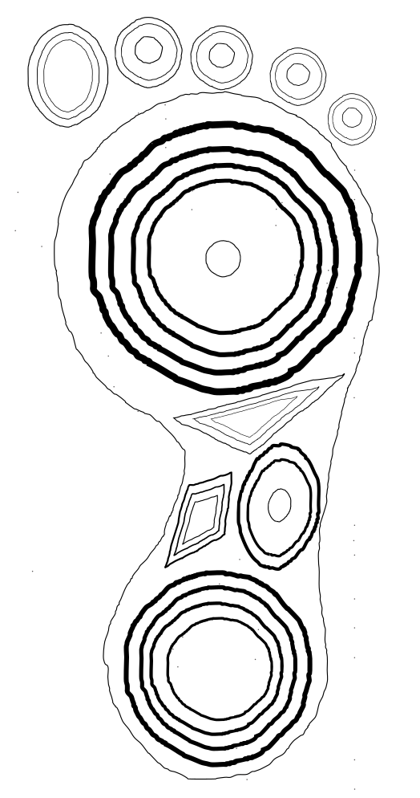

Electricity

* I leave lights on and electric appliances after I am done using them
* I sometimes save energy
* I always save energy, every chance I get

Transportation

* I travel in a large car
* I travel in a small car
* I use public transport
* I ride my bike or walk when I can
* I always walk or take my bike

Dwelling

* I live in a 3+ bedroom house
* I live in 1 or 2 bedroom house
* I live in an apartment

Recreation

* I go on a lot of boat trips
* I often go to the cinema or restaurants
* I hang out at my friend’s house or my own

Waste

* I throw everything into the same bin
* I recycle paper
* I recycle and compost all waste

Water

* I never try to save water
* I try to reduce my water usage
* I save water any chance I can

Energy

* I keep the heat on all day
* I try to use less heat
* I save energy every chance I get

Food

* I eat meat everyday
* I eat meat 1 or 2 times a week
* I am a vegetarian/vegan

Consumption

* I buy everything I want and need
* I only buy what I need
* I buy eco-friendly products
* I buy very little, except food, and always consider its environmental impact

Food

* I do not check where my food is sourced from
* I check the labels on all food products I purchase
* I grow my own food